PRESTBURY PARISH COUNCIL RESPONSE TO PART 2 OF THE CHESHIRE EAST LOCAL PLAN: THE SITE ALLOCATIONS & DEVELOPMENT POLICIES DOCUMENT (SADPD) CONSULTATION
September 2019
INTRODUCTION
Paras. 1.3 – 1.4: Saved Policies
Prior to the establishment of Cheshire East unitary authority, Prestbury Parish fell within the district administrative area of Macclesfield Borough Council. In its Local Plan, Macclesfield recognised a number of low density areas (classified originally as H10 and later as H12) within the developed parts of Prestbury Parish (and also to some other areas such as Alderley Edge) which it was felt made a positive and important contribution to these areas. The Prestbury Village Design Statement (VDS), a Supplementary Planning Document to the former Macclesfield Local Plan, provided legitimate reasons as to how these areas contributed to the look and feel of Prestbury village.
The VDS recognises that different parts of the village have different densities. It says:
“More substantial garden plots tend to be associated with older and pre-war houses that were built, in the main, along the principal roads radiating from the centre. It is these larger properties with their well established gardens and mature trees which contribute to the distinctive visual quality of all approaches to the village centre. This applies to Chelford Road, Castle Hill, Macclesfield Road, Heybridge Lane, Prestbury Lane and Butley Lanes”
(Settlement Pattern: Density Recommendations and Guidance Notes, paragraph 2.4.1, page 14, Village Design Statement for Prestbury Parish, January 2008).
And also:
“Any new development must not only conform to the density in the part of the village in which it is taking place, but also to the scale of its immediate area. This will ensure that the spatial and landscape characteristics of that part of the parish are maintained as well as the low density which is the most important single defining characteristic of Prestbury”.
(The Built Environment, Recommendations and Guidance Notes, paragraph 2.8.1, page 19, Village Design Statement for Parish of Prestbury, January 2008). https://web.archive.org/web/20110715113019/http://www.prestburycheshire.com/design.pdf
No case has subsequently been made as to why these areas should not continue to be low density/ H12 areas. Either the Macclesfield Borough policies – which served the settlement of Prestbury well – should be ‘saved’/carried through to Part 2 of the Cheshire East Local Plan, the Site Allocations and Development Policies Document (SAPD), or Policy HOU 12 in the SADPD should be adapted for them.
It is also worth noting here that, although Cheshire East Council (CEC) has adopted the concept of local landscape character areas, it has not carried forward the designation of ‘Areas of Special County Value’ (ASCVs) which were inaugurated by Cheshire County Council – primarily because Cheshire had no Areas of Outstanding Natural Beauty. ASCVs were intended to offer some degree of protection at the local level whereas CEC’s local landscape character areas are primarily descriptive. Prestbury Parish Council and the Campaign to Protect Rural England lobbied CEC to retain ASCVs in their Local Plan, but they were not minded to do so.
A scanned map of the built part of Prestbury, taken from the last Macclesfield Borough Local Plan that was adopted, is presented in evidence to support the statements made here (Illustration 1).
Landscape image of Prestbury village scanned from Macclesfield Borough Local Plan adopted 2004
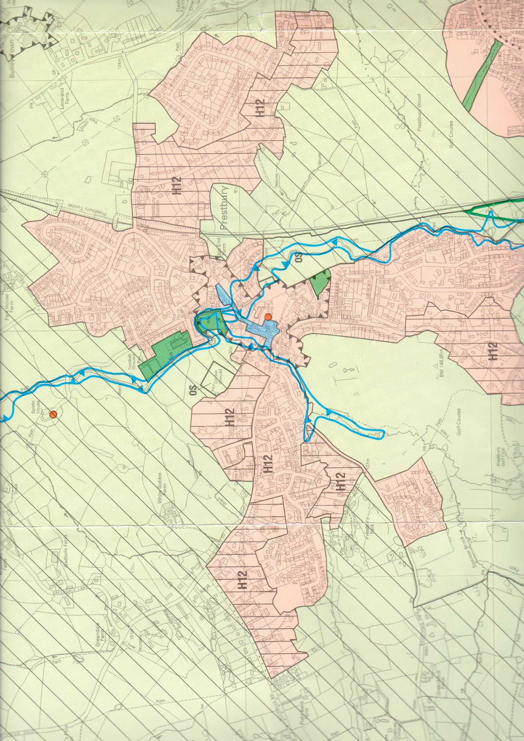
Illustration 1 Areas in pink are predominantly residential. Pink areas with vertical lines (H12) are low density housing areas. All light green areas are Green Belt and those with hatched lines are/were Areas of Special County Value (ASCVs). The two areas bordered by inward-pointing triangles are the Conservation Areas – the village centre and Butley Town (top right)
Paras. 1.5 – 1.9: Neighbourhood Planning
Whilst Prestbury has not conducted a Neighbourhood Plan exercise, it has previously carried out similar exercises which resulted in Supplementary Planning Documents (SPDs). The Parish Plan, ‘Plan for Prestbury’, which was lauded as best practice by ACRE (Action with Communities in Rural England), drew a phenomenal 57% response rate to its consultation exercise from households (http://www.cheshireaction.org.uk/uploads/documents/PrestburyParishPlan_Part1.pdf) and it resulted in an SPD: https://www.cheshireeast.gov.uk/pdf/Prestbury%20Supplementary%20Planning%20Document.pdf.
The Village Design Statement (VDS) survey drew a 33.3% response. (The unabridged VDS version: https://web.archive.org/web/20110715113019/http://www.prestburycheshire.com/design.pdf was declared by consultants working on behalf of Historic England’s predecessors, English Heritage, to be one of the 10 best in England). Consequently, the Parish Council – a key partner in both exercises – is well aware of the opinions and preferences of its community. The vast majority (nearly 90% in the VDS survey and only a little lower in the Parish Plan consultation) wished to see the Green Belt respected and retained intact and did not want to see housing sprawl. The VDS SPD opens its assessment of the ‘Built Environment’ with the words: “A defining characteristic of Prestbury is the low density of its housing”. https://www.cheshireeast.gov.uk/pdf/en-pp-spd-pstat.pdf
Paras. 1.10 – 1.13: National planning policy and evidence base
In its response to the first draft of the Site Allocations and Development Policies Document (SADPD), dated October 21st 2018, Prestbury Parish Council drew attention to the Ministry for Housing, Communities and Local Government (MHCLG) consultation, launched in September 2017, into the ‘Right Homes in the Right Places’. Issued to supplement the Housing White Paper ‘Fixing Our Broken Housing Market’, it set out a draft methodology for calculating local authority housing need. For Cheshire East this was 1,142 homes p.a. – compared to the 1,800 p.a. in the Local Plan Strategy. https://www.gov.uk/government/consultations/planning-for-the-right-homes-in-the-right-places-consultation-proposals based on http://www.cheshireeast.gov.uk/planning/spatial_planning/cheshire_east_local_plan/cheshire_east_local_plan.aspx.
Whilst Prestbury Parish Council is aware that the figures are not necessarily maximums and that there have subsequently been tweaks to the methodology, they do demonstrate that the Parish Council was correct to express concern about the amount of housing that Cheshire East was seeking during Part 1 of the Local Plan process.
In February 2019, the MHCLG published the results of housing delivery tests it had applied (https://www.gov.uk/government/publications/housing-delivery-test-2018-measurement, ref. ISBN 978-1-4098-5421-0) . They revealed that Cheshire East was delivering almost twice as many houses as it was required to between 2015 and 2018 (actual in brackets, requirement not in brackets):-
2015/16: 1,086 (1,536); 2016/17: 1,058 (1,762); 2017/18 – 925 (2,311). Total: 3,067 (5,610 = 183%).
Paras. 1.17 – 1.21: Adopted Policies Map
It is apparent from the draft adopted policies map (PUB 02) why the area around site PRE 1 near Prestbury village centre was designated as ‘low density’ (H12) in successive Macclesfield Borough Local Plans. Surrounding properties can clearly be seen to be large in size and sited in generous plots. However, it is proposed in the SADPD that it should accommodate 10 dwellings. This would require a level of density that is clearly out of keeping with the site’s immediate surroundings.
Whilst the other two sites in Prestbury proposed for development (PRE 2 and PRE 3) are both in Green Belt, they adjoin and are partially surrounded by low density areas, which were designated as H12 in the Macclesfield Borough Plan. However, the number of dwellings being considered for them both would produce densities that were totally at odds/out of character with their settings – especially when, in each case, natural ponds would need to be excluded from the equations.
Originally it was projected that PRE 2/ CFS574, a site of 1.86 ha., could accommodate 56 dwellings. This has since been reduced to 35. Nevertheless, this reduced number would still require a density which bears no resemblance to the adjoining properties on Prestbury Lane, Heybridge Lane and Meadow Drive. Especially as only part of the site is developable due to the water table.
There is no firm proposal yet for a set number of dwellings for PRE 3/FDR 2001 as this site to the east of the railway line is put forward for safeguarding, to be developed in the course of the next Local Plan. That said it states, in the Prestbury Settlement Report (PUB 40), that the 1.21 ha. site “is being considered for around 70 dwellings” (para. 4.117, page 29). This is extraordinary when judged alongside the very low density of the adjoining properties (which average of an acre per plot).
PLANNING FOR GROWTH
Policy PG 8 & paras. 2.1–2.5: Spatial distribution (and LSC Spatial Disaggregation Report: PUB 05)
Prestbury Parish Council do not support Policy PG 8, the evidence for which we demonstrate elsewhere in our submission is flawed and outdated. As mentioned in our comments on the SADPD ‘Introduction’, new housing is being delivered in Cheshire East much faster than was anticipated (https://www.gov.uk/government/publications/housing-delivery-test-2018-measurement) – a strong indicator of the desirability of the area to developers. Also, it is apparent from the housing completion figures up to March 30th 2019, released by CEC in August, that 3,197 of the 3,500 homes required from the 13 Local Service Centres (LSCs) have already been built or committed: (https://www.cheshireeast.gov.uk/pdf/planning/spatial-planning/researchand-evidence/housing-monitoring-report/housing-fact-sheet.pdf). In order to achieve the figure of 3,500, only a further 303 need to be delivered in the remaining 11 years of the Local Plan – an average of 2.1 per LSC p.a.
It is understood that the figure of 3,500 is not necessarily a ceiling. Prestbury Parish Council is aware of CEC’s ‘Approach towards housing supply flexibility in the SADPD’ (FD 47) which describes how the LPS provides for an additional supply of homes equivalent to 6.5% of the Plan’s overall housing requirement (ie. up to 38,352 from 36,000). But this percentage is an average. The proposed ‘flexibility factor’ for LSCs equates to 7.1%, meaning that CEC consider it acceptable for the LSC figure to be 3,749 – although FD 47 then explains that, adding on the figure of 1,375 homes to allow for windfalls, (raising the total to 40,124) increases the overall level of flexibility to 10%. It is inexplicable as to why windfalls should be added onto the requirement rather than removed from it (pages 2 & 3) but the key point to make is that going above the base figures could have negative consequences for Green Belt and the environment. CEC accepts this point. In the SADPD they say:
“Achieving the right balance of development in rural areas is a particular challenge; providing too much risks adversely affecting the character of the countryside” (para. 2.1).
This being the case, CEC should re-evaluate what it is asking for from the LSCs as the figures raise serious questions about the case for any further development in them. And their situation needs to be set against the bigger picture which appears to show that CEC are on course to deliver circa 42,000 homes in the Plan period (compared to 36,000 in the Local Plan Strategy) once contributions from the strategic sites are taken into account. See Table 1, compiled by Prestbury Parish Council.

CHESHIRE EAST STRATEGIC SITES: HOUSING STATUS AT MARCH 31ST, 2019
HOUSING REQUIREMENTS IN PART 1 OF THE CEC LOCAL PLAN/THE LOCAL PLAN STRATEGY VERSUS HOUSING PERMISSIONS, NOS. UNDER CONSTRUCTION & NO. OF COMPLETIONS

Strategic site | LPS housing requirement | No. accounted for by permissions/ being under construction/ completions | Residual housing not  yet delivered | Housing no. above  LPS figures
LPS 1 Central Crewe | 400 | 0 | 216
LPS 2 Basford East, Crewe | 850 | 490+ 325= 815 | 35
LPS 3 Basford West, Crewe | 370 | 370 | 0
LPS 4 Leighton West, Crewe | 850 |  | 850
LPS 5 Leighton, Crewe | 500 | 400 | 100
LPS 6 Crewe Green | 150 |  | 150
LPS 7 Sydney Rd., Crewe, inc. extension | 525 | 240+ 275 + 12= 527 | 0 | 2
LPS 8 South Cheshire Growth Village, Wychwood, Weston, nr. Crewe | 650 |  | 650
LPS 9 Shavington/ Wybunbury Triangle | 400 | 364 | 36
LPS 10 East Shavington | 275 | 275 | 0
LPS 11 Broughton Road, Crewe | 175 | 129 | 46
LPS 12 Central Macclesfield | 500 | 0 | 264
LPS 13 South Macclesfield Devt. Area | 1,050 | 950+ 150 = 1,100 | 0 | 50
LPS 14 Land East of Fence Ave., Macc. | 250 | 300 |  | 50
LPS 15 Congleton Road, Macc. | 300 |  | 300
LPS 16 South of Chelford Rd, Macc. | 200 | 232 |  | 32
LPS 17 Gaw End Lane, Macc. | 300 | 0 | 40+310*=350 | 50
LPS 18 N. of Chelford Rd, Henbury, Macc. | 150 | 33+ 135 = 168 |  | 33
LPS 20 White Moss Quarry, Alsager | 350 | 350 | 0
LPS 21 Twyfords/ Cardway, Alsager | 550 | 373-1 (1 demolished) = 372 | 178
LPS 22 M/c Metro. Uni. Alsager Campus | 400 | 229 + 207 = 436 |  | 36
LPS 26 Back Lane, Congleton | 750 | 83+ 140+200+ 275+203 = 901 | 667 | 234
LPS 27 Congleton Business Park | 625 | 0 | 625
LPS 28 Giantswood Lane Sth. Congleton | 150 | 131 | 19
LPS 29 Giantswood - M/c Rd. Congleton | 500 | 0 | 500* | 350
LPS 30 M/c Rd. - Macc. Rd., Congleton | 450 | 107 + 201 = 308
LPS 31 Tall Ash Farm, Congleton | 225 | 236 |  | 11
LPS 32 Nth of Lamberts Lane, Congleton | 225 | 38+ 34+ 38+ 120 = 230 |  | 5
LPS 33 N. Chesh. Growth Village, Handforth | 1,500 |  | 1,500
LPS 34 Clay Lane - Sagars Rd Handforth | 250 | 250 | 0
LPS 36 North West Knutsford (A, B & C) | 500 | 190 | 75+300*=375 | 65
LPS 37 Parkgate Extension, Knutsford | 200 | 200 | 0
LPS 38 South of Longridge, Knutsford | 225 |  | 225
LPS 42 Glebe Farm, Middlewich | 525 | 450 | 75
LPS 43 Brooks Lane, Middlewich | 200 | 0 | 200
LPS 45 Warmington Lane, Middlewich | 235 | 235 | 0
LPS 46 Kingsley Fields, Nantwich | 1,100 | 324+ 319+ 360 = 1,003 | 97
LPS 48 Hazelbadge Rd., Poynton | 150 |  | 150
LPS 49 Spink Farm, Poynton | 150 | 150 | 0
LPS 50 Chester Rd., Poynton | 150 | 150 | 0
LPS 53 Junction17, M6, Sandbach | 450 | 138+ 50 + 237 = 425 | 25
LPS 54 Royal London, Wilmslow | 175 | 60+ 120 = 180 |  | 5
LPS 56 Stanneylands Rd., Wilmslow | 200 | [Figure reduced from 200] 174
LPS 57 Heathfield Farm, Wilmslow | 150 | 161 |  | 11
LPS 61 Alderley Park, Alderley Edge | 275 | 81+ 95 + 73+ 57+ 50 = 356 |  | 81
TOTAL EXPECTED | 18,555 | 11,568 | 7,633 | 1,015
Table 1 compiled by Prestbury Parish Council, September 2019 with some assistance from Cheshire East Council (CEC)
* Subject to 106 agreement at March 2019 and therefore cannot be counted as having permission.
NOTES: CEC’S published completions figure of 34,319 does not include strategic sites without planning permissions but does include sites awaiting 106 agreements. Column 1 shows that strategic sites in the Cheshire East LPS, were expected to deliver 18,555 houses (min). At March 31^{st,} 2019, (11 years before the end of the Plan period), 11,568 houses on strategic sites alone had permissions, were under construction or had been completed. (NB. Figure of 0 against LPS 1 and 12 was CEC’s advice). Adding the 7,633 that were outstanding to CEC’s figure of 34,319 gives a figure of 41,952. (CEC’s LPS housing figure is 36,000).
Local Service Centre Spatial Distribution Disaggregation Report

CES’s ‘Local Service Centre Spatial Distribution Disaggregation Report’ (ref. PUB. 05) gives a major reason for “some modest growth in housing and employment” in LSCs as being:
“to reduce the level of out commuting” (para. 6.2)
Yet it is revealed that:
“Prestbury and Alderley Edge (two other settlements where home-based working is particularly prevalent) are unusual in having net in-commuting for work, primarily from the Principal Town of Macclesfield” (para. 5.12).
Also, Prestbury is not listed as an area of high housing need in the north of the borough. Alderley Edge, Chelford, Disley and Mobberley are listed as having “a high rate of housing need” (para. 5.11).
Although the LSC Spatial Distribution Disaggregation Report (PUB 05) is dated June 2019, the figures it quotes in respect of housing completions, take-up and commitments are those up to March 31st, 2018 (para. 9.1). Paras. 2.2, 4.6 and the ‘Infrastructure’ section claim that the residual number of dwellings required across the 13 LSCs is 406. However, the actual position, according to CEC’s own figures released in August 2019, (as stated above in response to Policy PG 8 and paras 2.1 – 2.5), is that only 303 dwellings were left to deliver as of March this year in order to reach the figure of 3,500 which appears in Part 1 of the Local Plan. (https://www.cheshireeast.gov.uk/pdf/planning/spatial-planning/researchand-evidence/housing-monitoring-report/housing-fact-sheet.pd).
Such a relatively modest figures across the 13 centres will almost certainly be accounted for by windfalls over the remaining 11 years of the Local Plan as it only requires each LSC to provide an average of 2.1 dwellings per year. The Local Plan Strategy only makes an allowance’ of 1,375 units for small sites for the entire 20-year period of the Plan (Table 8.2, page 55). In reality, in the last three years, 573 windfalls have come forward across the 13 LSCS – an average of 191 per year.
The matter of ‘Utilities’ is dealt with in a cursory way in PUB 05 - under ‘Infrastructure’ (paras. 9.6 – 9.8. Sewage is only mentioned in relation to the capacity of sewage infrastructure networks (para. 9.7). There is no recognition of the fact that there are no sewage networks in many rural areas. Two of the sites identified for development in Prestbury, PRE 2 and PRE 3, are not connected to sewage networks. Septic tanks service the nearest properties – on Prestbury Lane and Heybridge Lane.
It is revealed, under ‘Health Facilities’, that “the Eastern Cheshire Clinical Commissioning Group has highlighted a concern with regards to the capacity at the GP practices in Alderley Edge, Chelford and Mobberley” (para. 9.12). It is clearly not recognised that the National Health GP services in Prestbury are an off-shoot of the Alderley Edge Medical Practice, serviced by the same over-subscribed doctors.
In para. 11.5, under ‘Policy and Physical Constraints’, the Local Landscape Areas to the north west, south and south east of the built areas are not flagged up (see Draft Adopted Policies Map, ref. PUB 02, page 46: https://moderngov.cheshireeast.gov.uk/ecminutes/documents/s70972/Append).
In addition, there are further errors/ omissions under the ‘Historic Environment and Heritage’ section. Table 8, ‘Heritage Assets’, states that Prestbury has “One Conservation Area and some Listed Buildings”. Prestbury Parish has two Conservation Areas – one in the village centre and the second at Butley Town in the east of the Parish which is depicted in the top right hand corner of the scanned map (Illustration 1) included in this submission. Also, within the village centre, Prestbury has 30 listed buildings and three listed structures and outside the centre there are a further 20 listed buildings within the parish. Fifty listed buildings does not, by any measurement, constitute “some”.

Regarding ‘Flood Risk’, (covered in PUB 05, paras. 11.12 – 11.14), it needs to be recognised that site PRE 1 off Castle Hill which is proposed for development lies adjacent to the Bollin Valley flood plain. And, as the spatial distribution disaggregation report points out, “there are areas adjacent to the brooks and rivers that are at risk of flooding” (para. 11.14). Site PRE 2 has a brook running through it and a pond and a significant section of the land is almost permanently boggy. Meanwhile PRE 3 also has a large (mapped) natural pond (a tarn on the hillside), a landscape feature which means that part of this area (home to a brick works many years ago) is similarly boggy despite being on a hillside.
The Green Belt chapter lists, in Table 10 on page 31, the fact that Green Belt parcel PRO 9 is deemed to make ‘a significant contribution’ to Green Belt purposes. It is part of this parcel which has been carved out to make site PRE 3 (for safeguarding) for future development. Prestbury Parish Council has much more to say about this elsewhere in its submission on Part 2 of the Local Plan, the SADPD.
Under ‘Summary of Constraints and Opportunities’, the erroneous statement that Prestbury has only one Conservation Area is repeated (para. 16.1, page 47). Prestbury has two Conservation Areas – one in the village centre and one at Butley Town – the latter being washed over by Green Belt.
Here it is claimed that there are “several” listed and locally listed buildings. As stated earlier, there are in fact 50 listed buildings in the whole parish of Prestbury. Fifty does not constitute ‘several’. Also, missing from here (again) is any reference to the Local Landscape Designations that exist to the north west, south and south east of the built areas. (See the Draft Adopted Policies Map, ref. PUB 02, page 46). A Local Landscape Area adjoins site PRE 1, identified for development, and another encompasses site PRE 3, identified for safeguarding.
Further errors appear in Table 15 on page 54 which lists the services and facilities that were taken into account when examining Option 3 as an alternative for deciding spatial disaggregation. This is relevant because the hybrid methodology that was adopted – Option 7 – was a combination of Option 3 (services and facilities led), Option 4 (constraints led), Option 5 (Green Belt led) and Option 6 (opportunity led). It is important to set the record straight. Prestbury does not (as listed) have a bank or a newsagent or a specialist food shop. (It does have a convenience store but it does not have a supermarket within one km as required by the LPS, table 9.1). No permission exists for a take-away food business and, as stated earlier, it does not have its own dedicated National Health GP practice. The one it has is an off-shoot of the over-subscribed Alderley Edge Medical Centre.
Option 3, consisting as it does of a significant degree of misinformation, results in Prestbury being allocated 302 dwellings. On the other hand, Options 4 (constraints led) and 6 (opportunity led) result in extreme allocations at either end of the scale – with Option 4 allocating 0 dwellings to Prestbury and Option 6 allocating 409. Option 5 (Green Belt led) allocates 69 dwellings. Before applying a sustainability appraisal, the median of the four figures is 195, a figure which would be lower if the facts behind option 3 were correct. The report moves on to conclude that, with other factors taken into account, Prestbury should deliver 115 home in the plan period 2010-2030.
The settlement profiles at the end of the report are all based on outdated statistics. The housing tenure figures date from 2009, the numbers of dwellings are from the 2011 census and the economic information compares the census information from the 2001 census with the 2011 one. Extraordinarily, the LSC Spatial Distribution Disaggregation Report makes no reference to any of the other Cheshire East Council evidence documents that have been accumulated for Part 1 or Part 2 of the Plan. The most up-to-date statistics – for housing completions (as at March 2018) – were pre-empted by the release of more recent figures – up to March 2019 – at the same time the consultation on the SADPD was launched. The figures which are quoted are from such a wide sweep of time that is not possible to glean a clear picture or to make sound judgements from them.
This report is quoted as being the key evidence base for the decisions made about how many dwellings should be allocated to which LSC. As demonstrated, it is a seriously lacking document. (The errors flagged up here are only for Prestbury. It is quite likely that there are similar mis-reportings for other centres). If a realistic allowance were made for windfalls across all the LSCs, bearing in mind that they have been delivering an average of 191 windfalls each year for the last three years, then there should be no need to allot further housing to any of them in the SADPD. Or, where real evidence exists for some centres to accept development, it need not be substantial.
Policy PG 11, Green Belt and Safeguarded Land, paragraphs 2.15–2.17, the Prestbury Settlement Report (PUB 40) and the Green Belt Boundary Alterations Explanatory Note (PUB 56)
Prestbury Parish Council do not support Policy PG 11. Further Green Belt incisions are not necessary on top of those made in Part 1 of the Local Plan. Prestbury in particular should not be required to sacrifice more Green Belt, having lost over 20 ha (50+ acres) to a large new private grammar school site now under construction which will place significant extra demands on the local road system.
The Green Belt Boundary Alterations Explanatory Note (PUB 56) points to a ‘Vision for Local Service Centres’ associated with Policy PG2 on the ‘Settlement Hierarchy’ in Part 1 of the Cheshire East Local Plan, the Local Plan Strategy (LPS) and quotes from it:
“In the Local Service Centres, some modest growth in housing and employment will have taken place to meet locally arising needs and priorities, to reduce the level of out-commuting and to secure their continuing vitality. This may require small scale alterations to the Green Belt in some circumstances” (para. 2.19, PUB 56, quoting from para. 8.30 of the LPS).
However, Cheshire East’s own Local Service Centre Spatial Distribution Disaggregation Report flags up the fact that Prestbury has in-migration (para. 5.11). Consequently, it does not need to “reduce the level of out-commuting”. As to the point about vitality, at the time this submission was prepared (September 2019), only one commercial property in the village centre was empty and seeking a tenant and the community supported a large number of restaurants, clubs, societies and activities.
The ‘Approach Towards Small Sites’ evidence document (PUB 58) quotes the National Planning Policy Framework’s (NPPF’s) recognition of the contribution that can be given to housing figures by small sites. It highlights the requirement in the NPPF that at least 10% of a local authority’s housing should be on sites no larger than one hectare and it goes on to say:
“The Cheshire East Local Plan Strategy (LPS) established the objectively assessed need for 36,000 new dwellings over the plan period, an average of 1,800 dwellings per year”.
10% of the adopted housing requirement of 36,000 new dwellings is 3,600 new homes. This document identifies sources of supply for small and medium sized sites of 1 hectare or less and demonstrates that when taking into account of sites identified in the Brownfield Land Register; commitments; allocated sites proposed for allocation in the SAPD, at least 10% of the LPS housing requirement can be identified on land of 1 ha or less” (Paras. 1.2/3, PUB 58).
It should be noted that neither of the two Prestbury sites which are identified in SADPD Policy PG 1 for removal from Green Belt meet the ‘1 hectare or less’ criteria. They therefore do not contribute to Cheshire East’s target. Site PRE 2 ‘Land south of Prestbury Lane’ (xii in Policy PG 11) is 1.86 ha. in size and site PRE 3 ‘Land off Heybridge Lane’ (xiii) is 1.21 ha. Similarly, the following sites in Policy PG 11 do not contribute to CEC’s ‘1 hectare or less’ target: ALD 2 ‘Ryleys Farm, north of Chelford Road, Alderley Edge (6.67 ha); ALD 3 ‘Ryleys Farm safeguarded’ (7.70 ha); BOL 1 ‘Land at Henshall Road, Bollington’ (2 ha) or CFD 2 ‘Safeguarded land east of Chelford Railway Station (7.8 ha).
In the Local Plan Strategy the emphasis in relation to Local Service Centre development is on ‘small scale’, ‘sustainability’ and ‘retaining character’. Policy PG2 says:
“In Local Service Centres, small scale development to meet needs and priorities will be supported where they contribute to the creation and maintenance of sustainable communities”
Supporting paragraph 8.34 says:
“In Local Service Centres and other settlements and rural areas, the Local Plan Strategy approach is to support an appropriate level of small scale development that reflects the function and character of individual villages”. (page 59)
The quote from PG 2 begs the question, how does granting planning permission for a large school complex on Green Belt (as has happened in Prestbury) align with this policy and should not the increased traffic from the 1,250 pupils, 210 staff and ancillary others be considered a factor of such relevance that it precludes any development sites being allotted to Prestbury? And how can para. 8.34 align with site allocations several times denser than adjoining low density housing and hope to retain the character of an area? In addition, the number of dwellings proposed for each of the three Prestbury sites pays no apparent heed to sustainability, openness, mass or views from Green Belt.
Paragraph 2.16 of the SADPD maintains that the requisite ‘exceptional circumstances’ (essential in order to justify the release of Green Belt) are met because of the need to provide the committed level of development in the north of the borough of Cheshire East. It says:
“As set out in the LPS (paragraph 8.48), the importance of allocating land to go some way to meeting the identified development needs in the north of the borough, combined with the consequences for sustainable development of not doing so, constitutes the exceptional circumstances required to justify alteration of the existing detailed Green Belt boundaries”.
The fact of the matter is that CEC is more than on course to deliver housebuilding to meet the committed development in the north of the borough and record levels of development have been taking place since 2010, producing over 90% of homes approved (Table 1 in this submission and also https://www.gov.uk/government/publications/housing-delivery-test-2018-measurement). In LSCs completions were such at March this year that the 13 LSCs only needed to deliver a further 303 dwellings between them in order to meet the figure of 3,500 by 2030 (2.1 homes average each p.a.) (https://www.cheshireeast.gov.uk/pdf/planning/spatial-planning/researchand-evidence/housing-monitoring-report/housing-fact-sheet.pdf). Such a modest residual figure is clearly achievable by windfalls as, in the last three years, 480 have been delivered this way.
Although evidence document FD 47 points to a Housing Supply and Delivery Topic Paper dated August 2016 which promotes a flexibility factor of 7.1% for LSCs, raising the joint potential housing requirement to 3,749 and adding on a further 1,375 for windfalls, the case is not made for this level of development. Nor has evidence been collected to show the environmental impacts of raising the LSC housing figures to these levels. CEC needs to demonstrate that it genuinely recognises its own warning/ stipulation with regard to over-development. It says in the SADPD:
“Achieving the right balance of development in rural areas is a particular challenge; providing too much risks adversely affecting the character of the countryside” (para 2.1)
The ‘exceptional circumstances’ for taking even more Green Belt for housing than Part 1 of the Local Plan identified have not been satisfactorily identified and the ‘exceptional circumstances’ arguments being used for Prestbury are particularly weak. Prestbury’s sites should be deleted from the SADPD.
Redesignation of Green Belt parcels
The Green Belt land proposed for safeguarding in Prestbury (referenced variously as PRE 3 and FDR 2001) was downgraded by CEC from making ‘a significant contribution’ to making ‘a contribution’. Prestbury Parish Council were so concerned about the redesignation downwards of land so recently given a high Green Belt rating and proffered as evidence for Part 1 of the Local Plan process by CEC that they asked CEC’s spatial planners to furnish information as to where else this had occurred – in other local service centres or elsewhere in Prestbury. This information was supplied and it revealed that there were two cases outside of Prestbury where part of or all of Green Belt parcels were given a lower designation (in Alderley Edge) after land was put forward in the ‘Call for sites’. These are also being promoted for removal from Green Belt. Within Prestbury parish there were five instances where downgrading has happened, although the other sites are not currently being promoted.
Green Belt Assessment Summary for Green belt sites proposed for removal in the publication draft SADPD
Site ref.  in SADPD | Site ref. in settlement  report | Site name | Site contribution  to Green Belt purposes | Site  within  GBAU  parcels | GBAU parcel  contribution to  Green Belt purposes
ALD 1 | CFS 301 | Land adjacent to Jenny Heyes, Alderley Edge | Contribution | AE 06 | Major  contribution
ALD 4 | CFS 130b | Land north of Beech Road, Alderley Edge | Significant  contribution | AE 04 | Major  contribution
PRE 3 | FDR 2001 | Land off Heybridge Lane,  Prestbury (northern site) | Contribution | PR 09 | Significant  contribution
Table 2
Green Belt Assessment Summary for Green Belt sites considered in the Prestbury Settlement Report
Site ref. | Site name | Site contribution to  Green Belt purposes | Site in  GBAU  parcels | GBAU parcel contribution  to Green Belt purposes
CFS 154 | Area A, Land at Bridge Green | Contribution | PR 12 | Significant contribution
CFS 197 | Land north of  Chelford Road and  west of Collar House Drive | Contribution | PR 19 | Significant contribution
FDR 1730 | Land off Macclesfield Road | Significant  contribution | MF13 | Major contribution
FDR 1916 | Yew Tree Barns,  Macclesfield Road | Significant  contribution | MF13 | Major contribution
FDR 2001/  PRE 3 | Land off Heybridge Lane,  Prestbury (northern site) | Contribution | PR 09 | Significant contribution
Table 3. Information in above tables supplied by Cheshire East Council
It can be seen from the top table that in three instances Green Belt land has been downgraded by CEC planners and then tabled for removal from Green Belt (in Policy PG 11 of the SADPD) and as being suitable for development. This cannot be supported. In any event, it is not necessary.
The bottom of the two tables above shows that four partial or whole parcels of Green Belt in Prestbury Parish have now been given lower designations than were originally awarded to them, the land off Heybridge Lane (northern site) being one of them. Reasons are given in PUB 40 as to why the other sites should not be released from Green Belt. Prestbury Parish Council contend that the Heybridge Lane site - and the Prestbury Lane site which has not been redesignated – both have equally strong reasons for not being released from Green Belt. Nor should they be as Cheshire East is on course to deliver the housing numbers they have committed to.
Prestbury Settlement Report
Following the ‘Introduction’ to the Prestbury Settlement Report (PUB 40), there is a statement that Prestbury does not have a Neighbourhood Plan and nor is there one in preparation. This is true, but - as a result of surveys carried out for the Village Design Statement (VDS) and the Parish Plan - Prestbury Parish Council understands where there are strongly held opinions in relation to planning matters, especially as both exercises had very high levels of consultation responses (33.3% for the VDS and 57% for the Parish Plan). Links to the documents which resulted from them are here:
The Unabridged Prestbury VDS: https://web.archive.org/web/20110715113019/http://www.prestburycheshire.com/design.pdf
The abridged VDS/ adopted as an SPD: https://www.cheshireeast.gov.uk/pdf/en-pp-spd-pstat.pdf
The Plan for Prestbury: http://www.cheshireaction.org.uk/uploads/documents/PrestburyParishPlan_Part1.pdf
The Supplementary Planning Document which resulted from the Plan for Prestbury: https://www.cheshireeast.gov.uk/pdf/Prestbury%20Supplementary%20Planning%20Document.pdf
The development requirements in Prestbury in PUB 40 are given as 115 dwellings, plus 0.01 ha. of employment land between 2010 and 2030. The report states:
“Prestbury has met its requirement for employment land, but there is a need to find further sites to meet the requirement for housing and safeguarded land” (para. 4.70).
However, Cheshire East’s own Local Service Centre Spatial Distribution Disaggregation Report (PUB 05) points up the fact that Prestbury has in-migration (para. 5.12). Consequently, it does not need to “reduce the level of out-commuting”. Nor, (according to para. 5.11 of the same report) is Prestbury an area of high housing need. Where, therefore, is the case for Prestbury – tightly constrained as it is by Green Belt – to find housing sites over and above what emerges through windfalls? Especially when consideration is given to the scale of development coming forward via the LDS in adjoining areas, notably the former Woodford Aerodrome site (half in Stockport) with which Prestbury has a boundary, Handforth’s North Cheshire Growth Village and strategic sites in Henbury and Macclesfield, not to mention many smaller sites in Poynton and Dean Row, etc. There will be traffic impacts on Prestbury and much increased competition for shared services and infrastructure.
The figures in this report are only up to March 31 ,2018. Figures up to March 31, 2019 were released at the same time the SAPD consultation was launched. Prestbury in fact had 27 commitments and 32 housing completions up to March this year. On top of that, CEC have taken into account a more recent permission for a further 13 dwellings. According to CEC’s methodology for calculating housing need in the LSCs, this leaves 43 dwellings to find in Prestbury Parish in this Plan period. CEC is asking for 10 from site PRE 1 in the village centre and 35 from PRE 2 on Prestbury Lane – two more than essential to make up their numbers. It is also not properly factoring windfalls into its calculations.
The minimum figure of 3,500 dwellings – to be attained cumulatively by all the Local Service Centres – was set by Part 1 of the Local Plan, the Local Plan Strategy, which was adopted in July 2017. The Parish Council accept, therefore, that it is a statutory consideration.
On the other hand, how that figure is disaggregated is a matter open to debate through Part 2 of the Local Plan. Prestbury Parish Council, in its response to the LSC Spatial Disaggregation Report, has pointed out a significant number of inaccuracies and omissions in that report. There could well be many more as the report was only judged from the perspective of Prestbury.
SITE ALLOCATIONS
Prestbury Parish Council do not support policies for Sites PRE 1, PRE 2 or PRE 3 which are all unsustainable and seem to be based on an over-reliance by CEC on the ‘Call for sites’ exercise.
Site CFS391 (referenced elsewhere as PRE 1)/Land at White Gables Farm, south of cricket ground
Prestbury Parish Council object to this site being selected for development and object to the density of development being proposed for it.
This 1.2 ha. site near the village centre lies behind houses on the north of the lower part of Castle Hill, abutting the cricket ground which is a protected open space. Sport England have advised there should be a specialist ball-strike assessment to inform any mitigation required (para. 4.29, PUB 40).
The settlement report’s response to the advice is: “Given the low-density nature of the development proposed, it is likely that a satisfactory layout and mitigation measures can be incorporated” (4.30). This very brief and dismissive comment makes no attempt to tackle the issues related to the sport and, the Parish Council suspects that the CEC is unaware of the fact that part of the land proposed for housing is used for car parking for the cricket club. Club members are desperately concerned that, without car parking, the club would suffer greatly. Prestbury Cricket Club has several teams, including junior level, and it is a well supported community asset. The cricketers, as with their counterparts everywhere, play with great enthusiasm and balls frequently land in the area being proffered for development. It is essential that Sport England’s recommendation is paid heed to and a proper ball strike assessment carried out. That said, it is also appreciated that such a survey could result in a recommendation for very high nets – and they, of course, would have other impacts.
Prestbury Parish Council would also point out that the density proposed for this site is not ‘low’ in relation to the immediate area. It is in fact ‘high’. (See Illustration 1). When the Parish Council made this point in a meeting it had with Cheshire East spatial planners, they suggested it might be apposite for the development on this site to consist of apartments. In response, the Parish Council wish to observe that if this in fact happened, then the development would be higher than a normal domestic dwelling and therefore the likelihood of a ball strike from the cricket field would be greater.
As illustration no. 2 in this submission – taken from the Environment Agency website – shows, the site lies adjacent to the Bollin Valley flood zone (https://flood-warning-information.service.gov.uk/long-term-flood-risk/map?easting=389808&northing=376927&address=100012367159). PUB 05 says: “There are areas adjacent to the brooks and rivers that are at risk of flooding” (para. 11.4).
This is the only SADPD site proposed for development in Prestbury which is not in Green Belt. That said, it adjoins Green Belt which is categorised as making a ‘significant contribution’ to Green Belt purposes. Also, the adjoining cricket ground and beyond has a Local Landscape Designation.
In addition, we note that the proposed access/ egress point for this site, (arrived at following some dispute over access), appears to be where there is a pedestrian crossing on Castle Hill. It is difficult to envisage where an alternative crossing point could be placed which would be safe and useful for the primary school’s ‘walking bus’ and for residents of Castlegate and beyond who use this crossing.
If, despite the issues raised by the Parish Council, the site receives endorsement, we would ask that some car parking facility is retained for the cricket club and that the number of units is reduced – allowing for a high quality, low density design which would suffer less ball strikes from the cricket field and generate less traffic at the difficult access/egress point. It is also essential that tree cover is retained and the pedestrian crossing point in the lower part of Castle Hill (the A538) is not lost or made less safe. Equally, the quality of design of any development must be of the highest standard.
Environment Agency flood zone map of area adjoining PRE 1
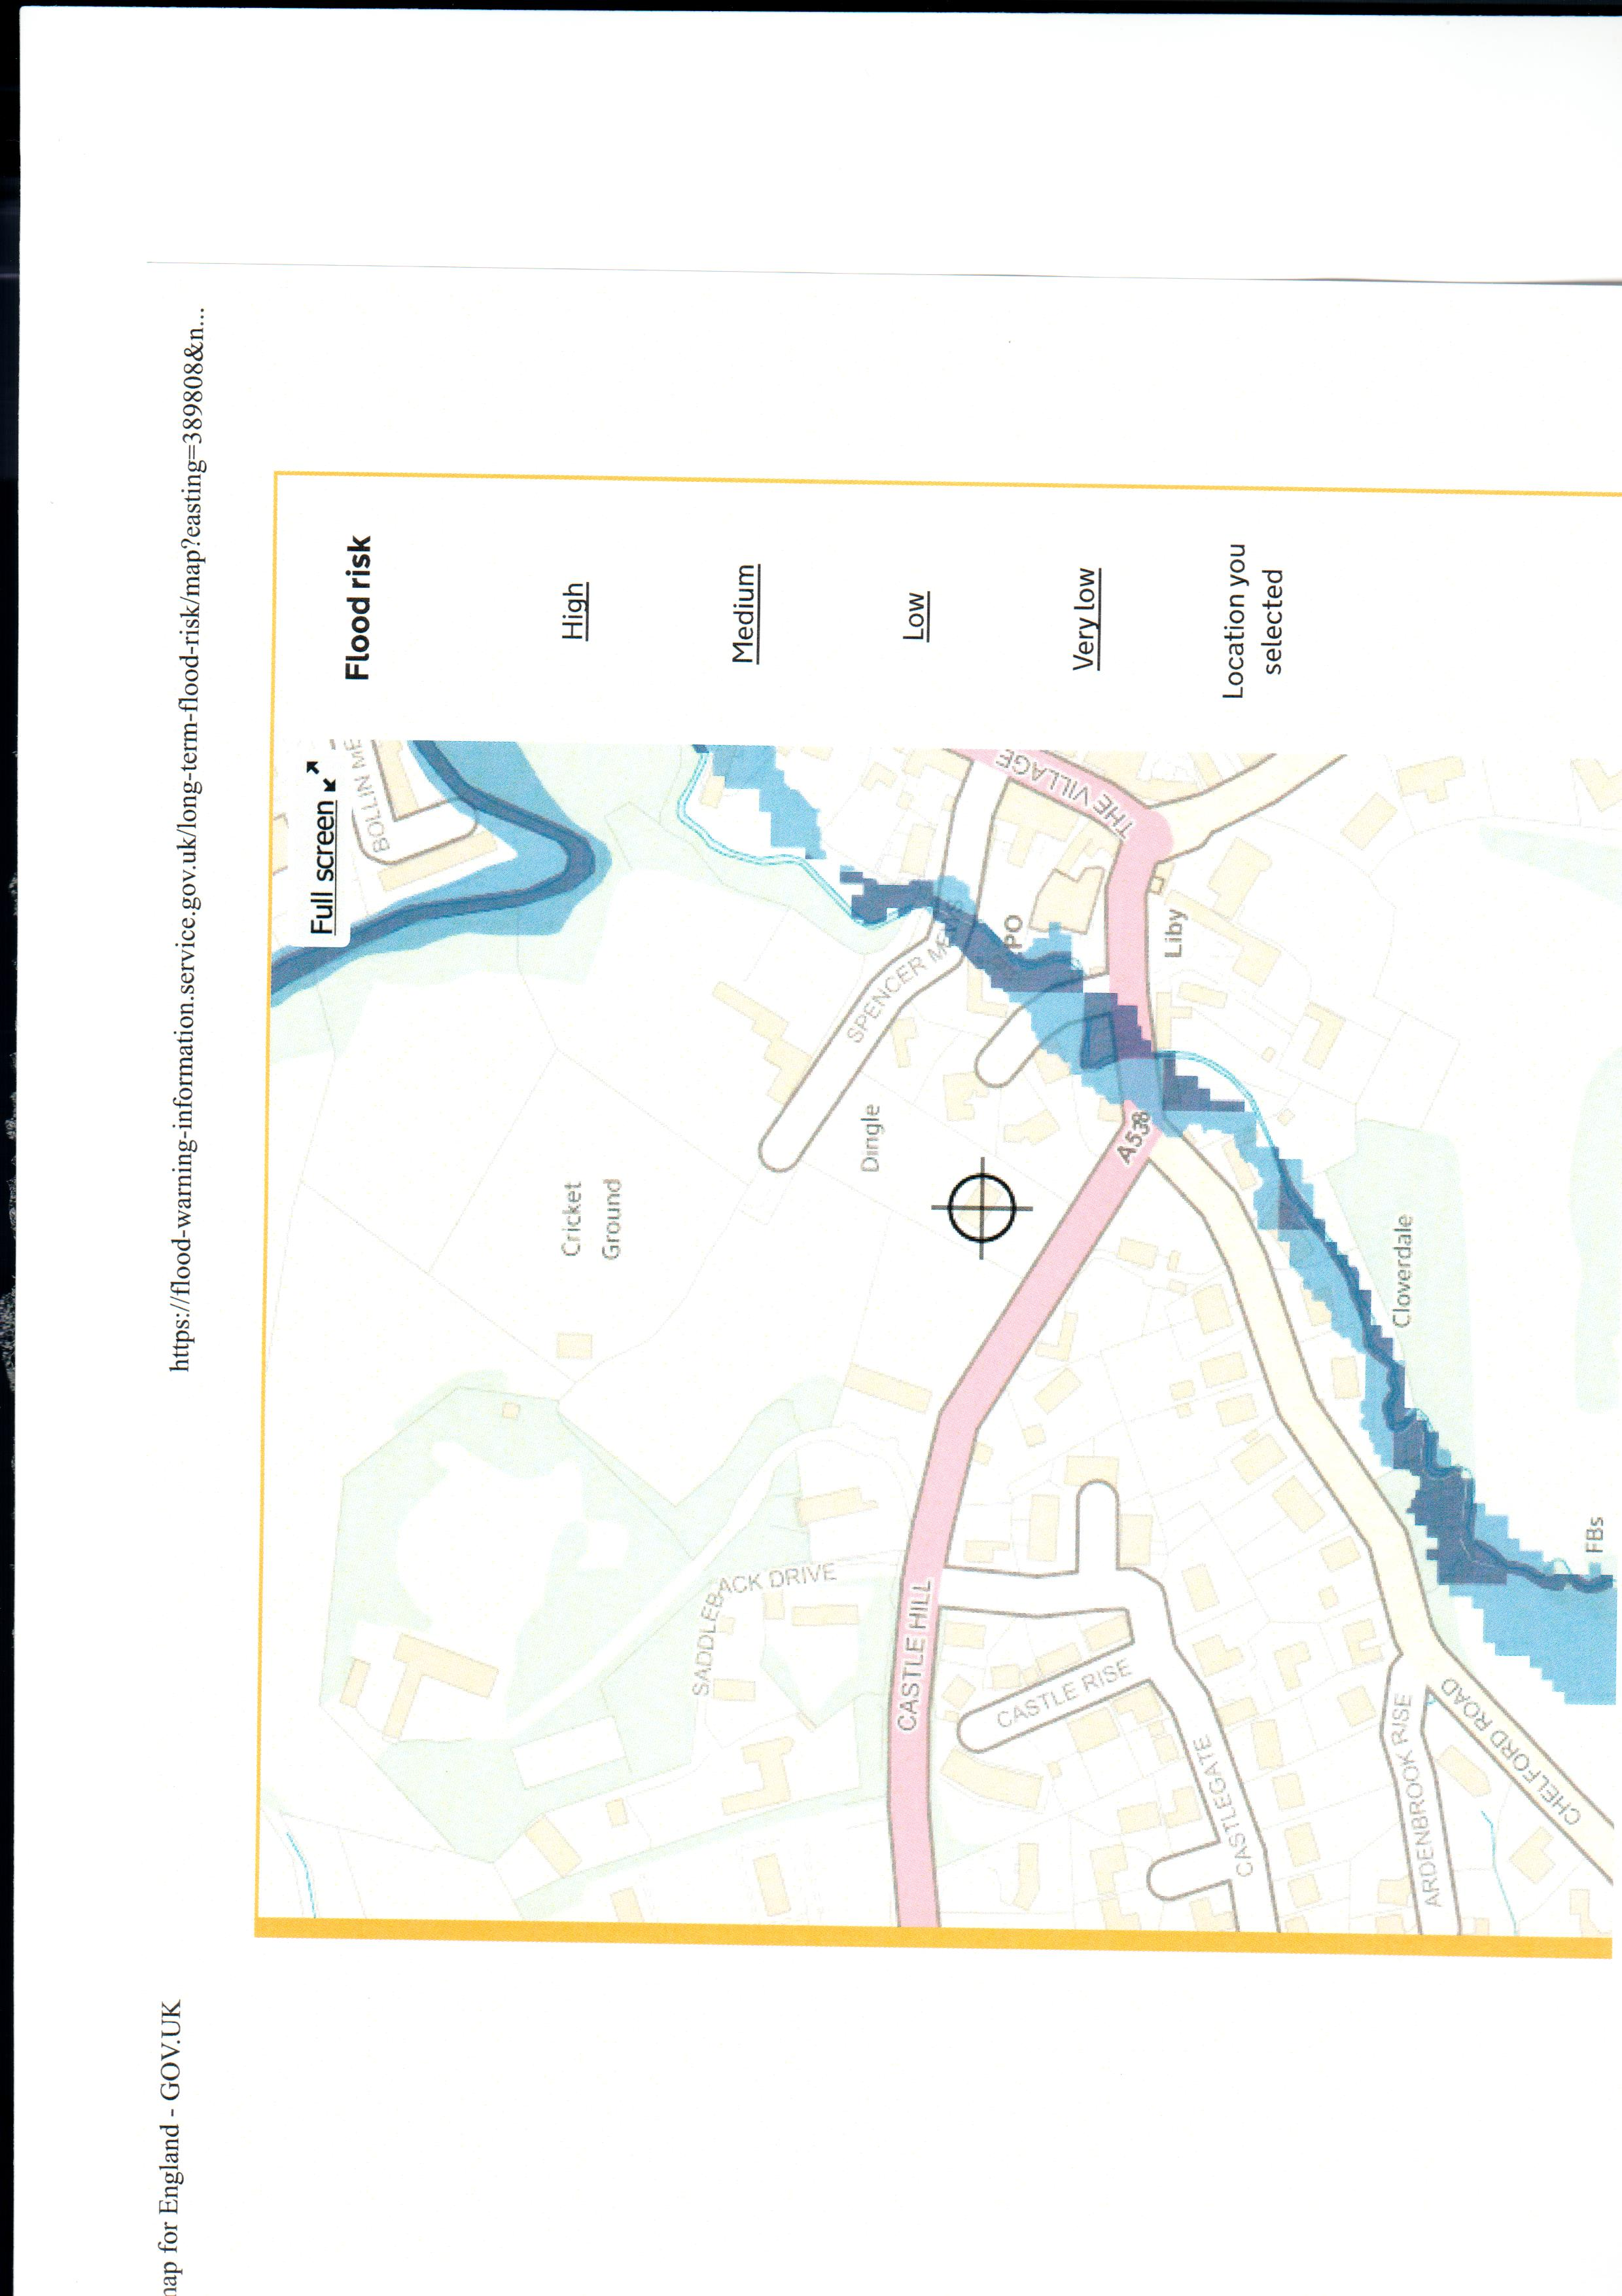
Illustration 2 The flood plain of Spencer Brook, which runs into the River Bollin to the north, adjoins the site

Site CFS574 (referenced elsewhere as PRE 2)/Land south of Prestbury Lane
Prestbury Parish Council object to the selection of the site and to the development density proposed. This 1.86 ha. site lies remote from the village centre on the south side of Prestbury Lane – an unclassified, sub-standard rural lane of varying widths with no pavement, road markings or lighting. In 1992 when the A523 was a trunk road, (it has since been de-trunked), the Department of Transport proposed an off-line new road should cross Prestbury Lane which then carried 5,000 vehicles per day.
The Settlement Report’s conclusion regarding this Green Belt site is that it “performs well through the site selection process” (para. 4.101, PUB 40). This, regardless of the fact that – in CEC’s own traffic light analysis – it scores ‘red’ on two issues (distance to employment areas and brownfield/ greenfield). In Prestbury Parish Council’s opinion, this site should also score ‘red’ on highway safety (CEC assess it as being ‘amber’). Accident statistics show it to be the most dangerous, from a traffic hazard viewpoint, of the three sites identified. The site should also score ‘red’ on landscape impacts.
Primary access to this site would be by motor vehicle and the vehicular access/egress to it would be via Prestbury Lane, a short distance from its eastern junction with the A523 London Road - which is the accident black spot in Prestbury Parish. A few hundred yards along the A523 to the south is the northern end of the Silk Road, a high standard single carriageway. Traffic leaving the end of the Silk Road heading north towards Poynton tends to carry on travelling at speed. Most accidents are caused because drivers waiting to emerge from the lane onto the A523 become impatient and dive out, often not realising the speed of oncoming traffic from the right in particular.
Whilst it is some time since there was a fatality at this junction (December 1st, 2004), serious injury accidents occur every few years (June 6th, 2015, July 10th, 2007 and September 1st, 2000) and slight injury accidents occur with depressing regularity (13 since 2000). (Statistics from Crashmap.co.uk). The number of non-injury accidents is unknown as these are not recorded but local residents are only too well aware of regular ‘shunts’, often causing closures, at either end of Prestbury Lane.
The western end of Prestbury Lane is so narrow that vehicles are required to take turns to pass each other. It is not an infrequent occurrence for drivers to misjudge their ability to pass each other and to become stuck and block the road. The extremely high verges either side of Prestbury Lane at its narrowest point near to its western junction with the A538/ Heybridge Lane have long been a major problem, but one considered too expensive to resolve as they are in fact the end of private gardens.
Local residents acquired, via Freedom of Information requests, some documents submitted by Anwyl Homes to Cheshire East Council in support of their pursuit of developing the Prestbury Lane site. These were passed on to the Parish Council and we would like to make the following comments:
Anwyl Homes promotional document, dated April 2019
The Parish Council do not concur with the following statements made in this document about the site:
- That it is a sustainable location for residential development and has a realistic capacity of 41
- That it has “excellent” pubic transport connections that include bus services to Alderley Edge
- That Prestbury has a residual housing requirement of 75 houses and shortfall of 20 dwellings
- That the natural pond on the site is in the later stages of succession
- That there is easy access to a foul water sewer and no utilities or infrastructure constraints
- That it would be appropriate to develop a larger area to the south of Prestbury Lane
- That the designation of making ‘a contribution’ to Green Belt was the ‘lowest available score’
- That development of the site would not lead to urban sprawl
- That the site makes no contribution to the special character of a historic town (or village)
- That the canvassed design, layout and density is appropriate to the setting
In response, we would draw attention to the following: our illustration no. 1 in this submission which depicts how this site lies on the extremity of the built areas and adjoins very low density housing; the fact that there is no bus service along Prestbury Lane and the limited bus service which does exist in the village does not connect to Alderley Edge, whilst the train services were recently reduced; the residual housing requirement for Prestbury is 43; the pond lies at the natural low spot in the valley and is essential for surface drainage; neighbouring properties on Prestbury Lane/Heybridge Lane are on septic tanks; the adjoining area that Anwyl would like to develop merited the classification of making a ‘significant contribution’ to Green Belt purposes; the designation of making ‘a contribution’ is not ‘the lowest available score’ – that of making ‘no contribution’ to Green Belt is; this site on the edge of a rural village would palpably lead to urban sprawl and affect the character of the eastern approach to it and the proposed layout bears no resemblance to anything on the village’s east side.
We also note that the facilities listed as being within two km. of the site feature seven in Bollington and Tytherington and six within Prestbury, wrongly labeling the Bridge Hotel as a ‘pub’ and failing to mention the two closest (Prestbury) pubs or Prestbury’s playing field, golf, tennis or cricket clubs.
Croft Preliminary Transport Issues Statement, February 2019
This is an illogical report which pays no heed to pedestrian safety. On the one hand it admits: “There are currently no formal footways on Prestbury Lane” (last paragraph, page 5). Yet, on the other, it goes on to simply measure the shortest distance – heading along Prestbury Lane in an easterly direction – to the nearest bus stop on the A523 London Road and to three places in Bollington and, in a westerly direction, to Prestbury railway station. Both would involve walking along Prestbury Lane – which is an untenable situation. The author of this report is also either unaware of the fact that bus services along London Rad (the A523) through Prestbury have ceased – or he is choosing to ignore the fact. See CEC public transport map below, updated in June 2019. (View link to the Cheshire East website: https://www.cheshireeast.gov.uk/pdf/public-transport/macclesfield-area-public-transport-map-18th-june-2018.pdf).
mid
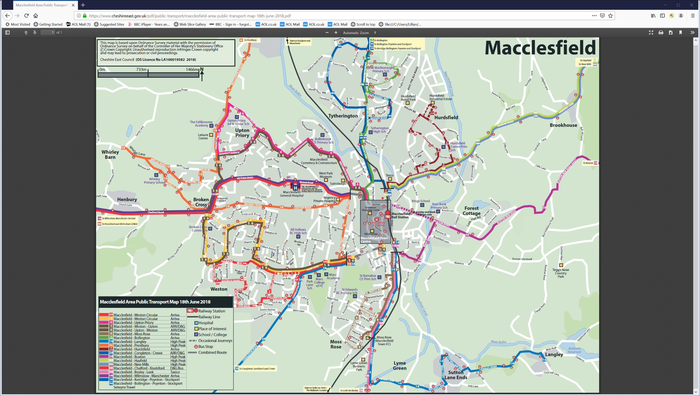
Illustration 3 ‘Orange’ no. 19 bus route, top of the map, runs through Prestbury village centre. The ‘blue’ no. 391/392 bus routes heads into Bollington. Note: Nothing heading north via A523/London Road to Prestbury.
Pedestrian Access Appraisal by GS Pearce Trust (undated)
This report also refers to the proximity of Prestbury Railway station to the site (450m from the boundary) but fails to explain that the only safe way to access it on foot would be to use the part of the ‘snicket’ footpath that lies to the east of Heybridge Lane in the first instance – assuming that access could be achieved to the snicket – and cross over Heybridge Lane. From the west side of Heybridge Lane, there would then be the option of either following the paved footway which does exist on that side of the road around over the railway bridge or using the remainder of the very steep snicket footpath down via Bridge End Lane to New Road and then turning northwards (right) up to the station. Either way, the distance is greater than quoted and the steepness of both options means they are only feasible for fit individuals.
[See the Parish Council’s comments under ‘Proposed Access on Foot’ below to currently unresolved legal issues relating to access from the proposed site PRE 2/CFS 574 to the ‘snicket’]
Paragraphs 1.1.6 refers to the lack of pedestrian-related accidents and to ‘shared surface lanes’. Referencing the ‘shared surface’ concept is something of a red herring. This works where there is ample highway width, proper visibility, good surfaces and adequate lighting – as in the case of the centre of Poynton. It is not a feasible proposition on a wending, unlit, uneven, badly drained rural lane which narrows in part to barely over one vehicle width where the road is permanently dark due to high embankments either side and tree canopies. Prestbury Lane has no record of pedestrian-related accidents for the simple reason that it is very rare indeed for anyone to risk walking along it.
Paragraph 3.3.12 points to the fact that “either a lack of footways or narrow footways are prevalent throughout the whole of the Prestbury settlement”. This is indeed the case in relation to a number of lanes around the area. It is a rural parish. But the commonality of poor footpath provision is not an argument for building a new development along a defective lane with inadequate or no footpaths.
As far as highway safety is concerned, the report’s author only examined statistics for the last five years and only looked at Prestbury Lane and Heybridge Lane – not the junction of Prestbury Lane with the A523 where accidents occur on the A523 London Road once traffic has left Prestbury Lane.
The situation in respect of this junction over the last five years is that, on June 6th 2015, there was a serious injury accident which involved two casualties. There were two slight injury accidents, each involving one casualty, on October 9th 2015 and October 2nd 2017 and a slight injury accident involving two casualties on October 13th 2017. (Reference: Crashmap.co.uk).
In addition, this report fails to make any mention of increased traffic which will be caused by the development of new strategic sites around Prestbury, by new highway capacity – some recently delivered (A555 Manchester Airport-High Lane road) and some in the planning (Poynton Bypass) not far away to the north – and by the large scale educational establishment currently being built in Prestbury which will draw new traffic movements into and through the village from every direction.
The GS Pearce Trust report merely goes on to conclude that, as there are no records of pedestrian accidents in the last five-year period, other than one in the centre of the village, this means that “pedestrians and vehicles interact safely, including where there are either no or narrow footways” (para. 3.46). Also in the summary: ”Whilst Prestbury Lane does not have existing footways, a review of the highway safety records show that the road has been safely utilised by vehicles and pedestrians during the full five-year study period” (para. 3.6.1). Either it has not occurred to the author or he has chosen to ignore the fact that very few individuals risk walking along the more rural lanes – and it would be an exceptionally rare occurrence for anyone to venture to walk along Prestbury Lane.
Proposed Access on Foot
The report proceeds to discuss the use of footpath no. 34, known locally as ‘the snicket’, as a primary pedestrian access to the PRE 2/CFS574 site. It does so in a manner which gives the impression that this is a foregone conclusion. The reality is that as of mid September 2019 when this submission was approved by Prestbury Parish Council, access from the site to this footpath was still mired in litigation.
The Parish Council was not/is not a party to the litigation as it does not own or rent any of the land involved. However, the key party has shared information with the Parish Council in order that the Parish Council is under no misapprehension that the matter has been sorted out. The key party has also shared with the Parish Council emails which confirm that Cheshire East Council has been made aware of the unresolved situation and we have been shown photographs of the aftermath of trees, bushes and hedges which were cleared from land by the would-be developer without the permission of the land-owner. This is as much as we can say on that matter.
We can, however, comment on the nature of ‘the snicket’ footpath. The western part of it is steep, narrow and it has a poor surface which is often slippy. It is not a feasible proposition for anyone with mobility problems, for people with buggies or for anyone encumbered by luggage or similar.
Prestbury Parish Council refute the statement that “Prestbury Lane could be utilised by pedestrians to access the site” (para. 4.2.3) and that it could provide a ‘Secondary Pedestrian Access’ (to the snicket) (para. 4.4). Such a proposition is based on defective assumptions, as is “Enhancing the environment” on the lane to make it more amenable. Walking along the lane would be a misguided and potentially deadly thing to do, even if speed management measures were applied as proposed.
Another issue of major concern to the Parish Council is the landscape impact of having a high density development appear on a major approach to the village which is currently very rural and open. The junction with the A523/ London Road is considerably higher than the bulk of Prestbury Lane – which drops away into a valley (where the new development would lie). Currently there is a sweeping vista of fields, hedgerows and scattered trees which creates a very particular impression of a rural settlement as people enter Prestbury from the major north-south road to the east. The few properties that do exist on the lane and the rear of properties on Meadow Drive which can be seen from this perspective are very low density with mature landscaping.
However, despite the fact that the other properties on Prestbury Lane sit in an average of a little under an acre of land each, the proposal is to accommodate some 35 dwellings on 1.86 ha (4.6 acres) of land, only part of which is likely to be developable. (There is a large mapped, natural pond on the site and much if it is boggy). This is totally out of keeping with what Macclesfield Borough Council classed as a low density/H12 area in its Local Plan before Cheshire East Council came into existence.
Regarding the pond, this acts as a natural drain for the fields, gardens and road. The speculative layout for the site appears to virtually ignore its existence and that of the stream along the eastern boundary which passes under Prestbury Lane through a culvert. There is a need for a detailed flood risk assessment to examine the impact of building in this low-lying area which, amongst other things, collects surface water from Meadow Drive.
The existence of so much water over time has created a diverse habitat, ranging from rushes to varied grassland, and it supports well established trees including oak, lime, ash and willow and a variety of wildlife including badgers. The Parish Council has also been presented with evidence that appears to show the existence of great crested newts in this very localised area. We append to this submission an email and images received to this effect. Clearly, a specialist amphibian survey will be essential – and the survey must be carried out during the government-recommended period for such surveys.
Preliminary Ecological Appraisal & Great Crested Newt Impact Assessment, May 2019
An ecological report was conducted on behalf of Anwyl Homes by United Environmental Services (UES) of Knutsford. An electronic version of it was obtained by local residents under a Freedom of Information request from Cheshire East Council and passed on by them to Prestbury Parish Council.
This initial report consists of a desk study and a record of an on-site assessment carried out on one day – March 4th 2019. In as far as great crested newts (GCNs) are concerned, the report says:
”The pond achieved an HIS score of 0.68, which indicates the waterbody is of ‘average’ suitability to support breeding GCNs” (para. 3.3.1, page 16, UES survey for Anwyl Homes)
Although it then went on to say that an environmental DNA (e DNA) test was returned as negative. However, it should be noted that the timing of the site visit was outside the government guidelines for this type of survey and for most others as well and on the extremes for two of the tests.
According to the official guidance supplied by Natural England to government, the timescale within which GCN surveys should be conducted is mid March to September (https://www.gov.uk/guidance/great-crested-newts-surveys-and-mitigation-for-development-projects#when-to-survey). This survey took place at the very beginning of March.
The table on the government website is replicated here:
GREAT CRESTED NEWTS SURVEYS AND MITIGATION FOR DEVELOPMENT PROJECTS, March 2015
When to survey
Survey method Best time to survey
Environmental DNA Mid April to late June
Egg search April – June
Pitfall traps March, April, May and September
Refuge search April to September
Bottle of funnel traps March to May
Netting Mid-March to mid-June (August to find larvae)
Torch survey Mid-March to mid June (August oi find larvae)
The survey comments that the pond, mapped as being on the south east side of the site closest to the gardens of 43 and 45 Meadow Drive, was 90% choked with greater reedmace, other reeds and decaying vegetation. Over 30 clumps of frogspawn were observed in the pond, which was surrounded by marshy grassland. There were also two other large areas of marshy grassland on the western and south western side of the site virtually adjoining the gardens of properties on Prestbury Lane and Heybridge Lane. This was in addition to the unnamed brook which was recorded as flowing alongside the northern section of the eastern site boundary which is surrounded by a woodland copse
The report also notes that there have been no official notifications of great crested newts from the area but advises that further eDNA surveys would need to be carried out on this and four other ponds within 250 metres of the site in order to establish for certain whether GCNs are or are not present. [Parish Council comment: Any further surveys must be conducted during the recommended periods].
An entrance hole to a badger sett was observed during the one day visit by UES and their report notes that there were 296 records of badgers and that five species of bats have been logged.
In addition, it was recorded that there is an historic, species-rich hedgerow running along the site boundary with Prestbury Lane which is shown on maps going back to 1850.
United Environmental Services recommended that a number of further surveys should be conducted.
Green Belt Ranking
According to the Green Belt Assessment conducted for Part 1 of the Local Plan by Arup, this parcel of land (ref. PR02) only makes ‘a contribution’ to Green Belt purposes. But the Arup report, published in 2015, did consider that the parcel made a ‘significant contribution’ in the category ‘Assist in safeguarding the countryside from encroachment’. (Page C107, Final Consolidation Report: https://www.cheshireeast.gov.uk/planning/spatial_planning/research_and_evidence/research_and_evidence.aspx). The ‘exceptional circumstances’ argument made by CEC is that “there are no other suitable alternatives that make ‘no contribution’ to Green Belt purposes”. This reasoning is based on the assumption that Prestbury has to find a residual total of 43 dwellings. It should not have to.
If, despite the issues raised by the Parish Council, this site is chosen for development, the numbers required of it must be reduced significantly to allow for a low density, high quality development that would have minimal impact on the ecology and landscape and contribute little traffic to the existing problems of Prestbury Lane – and the unsafe junctions at either end of the lane must be improved.

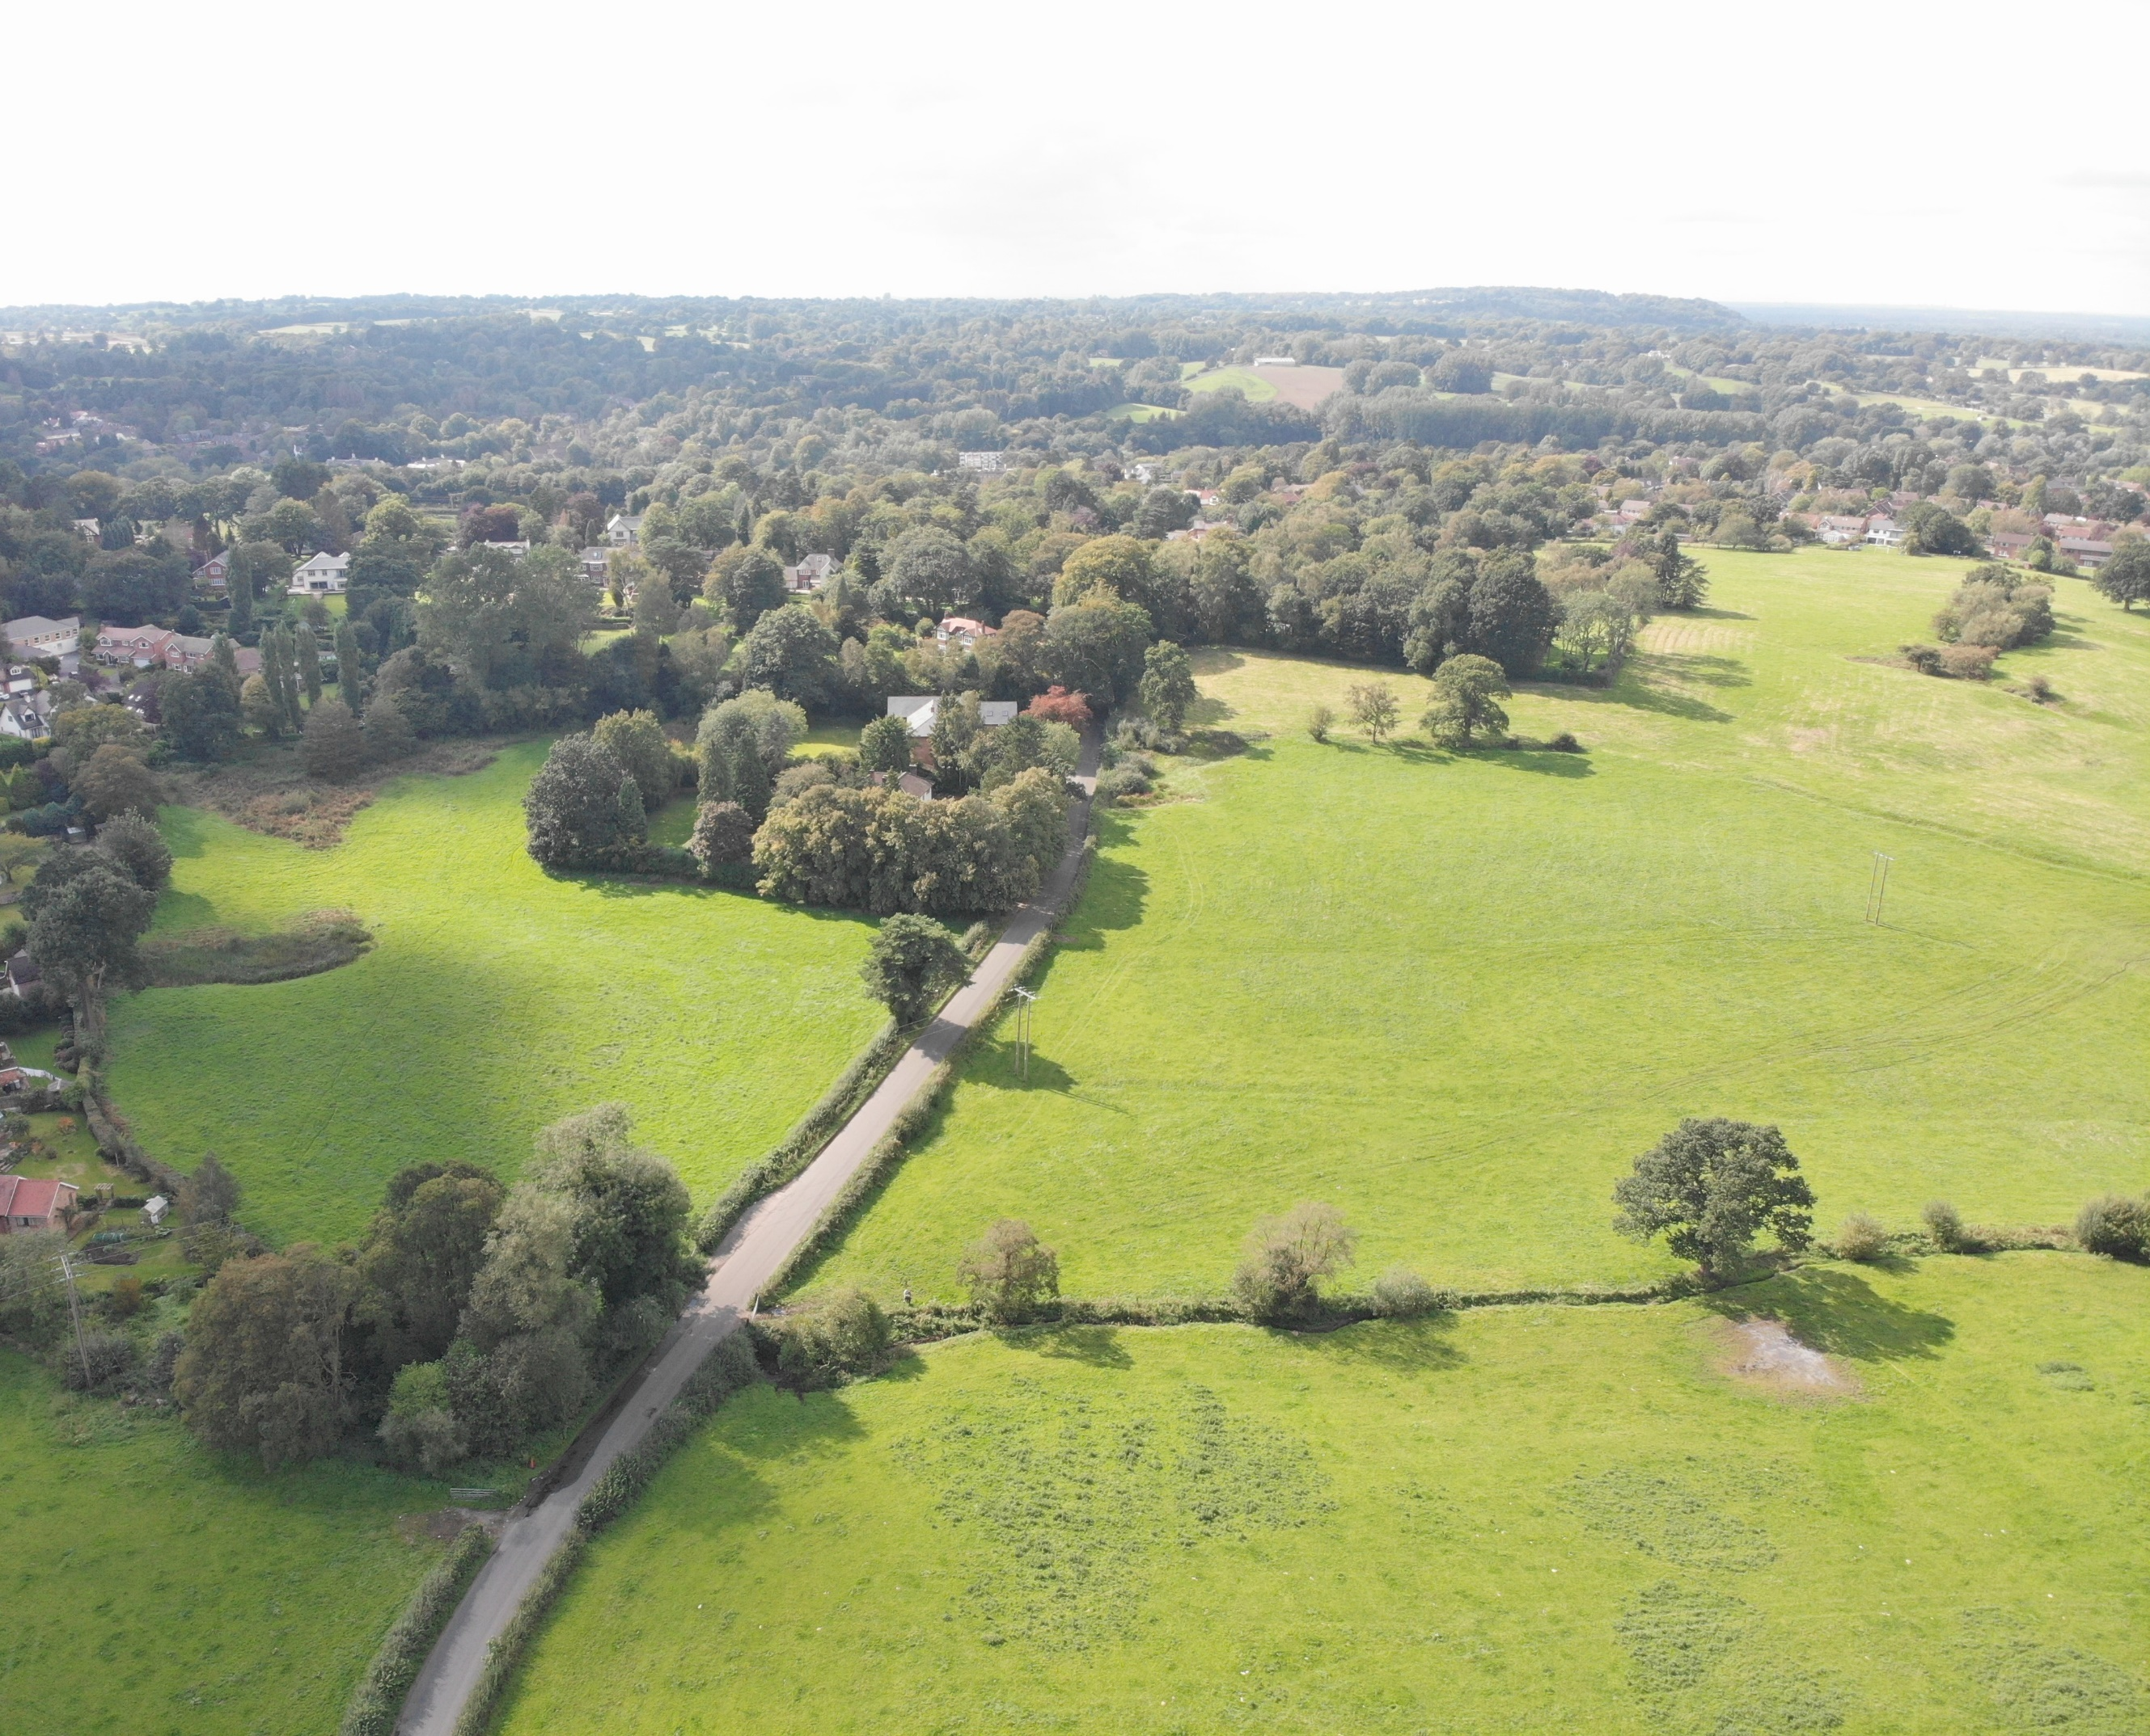
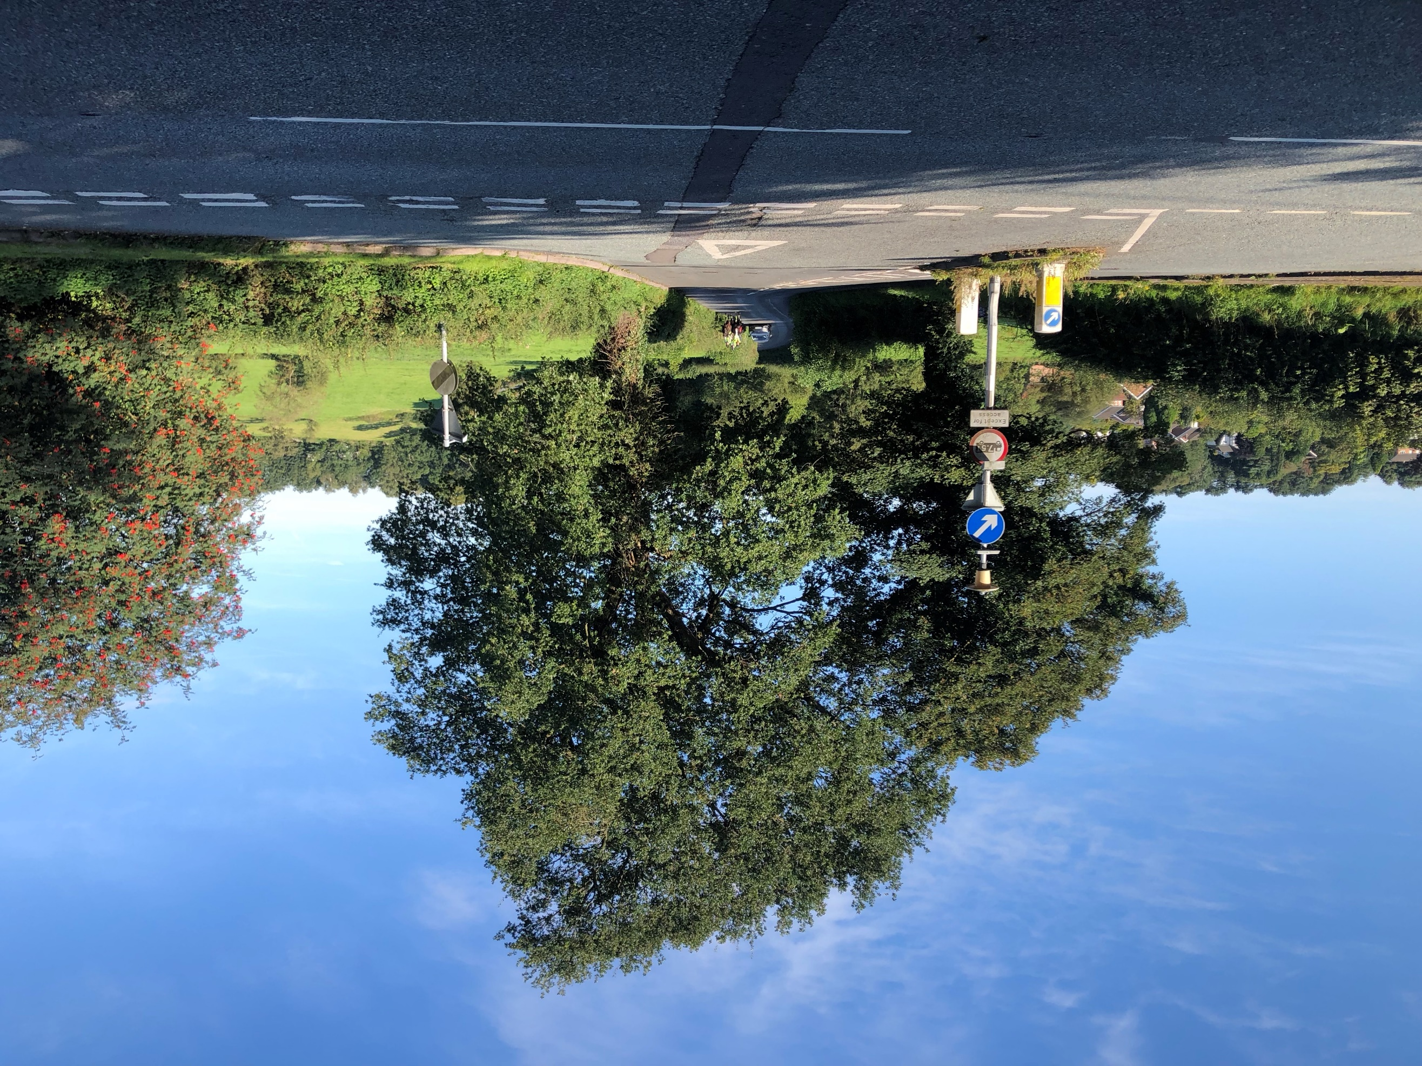

Prestbury Lane looking westwards towards Prestbury village The junction of Prestbury Lane with the A523/
London Road

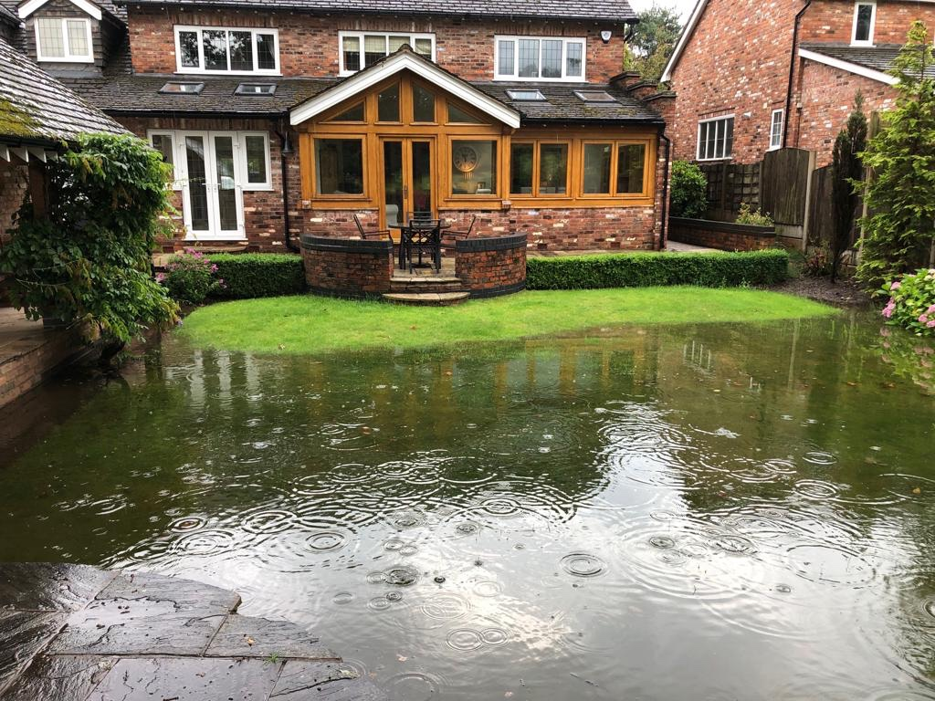
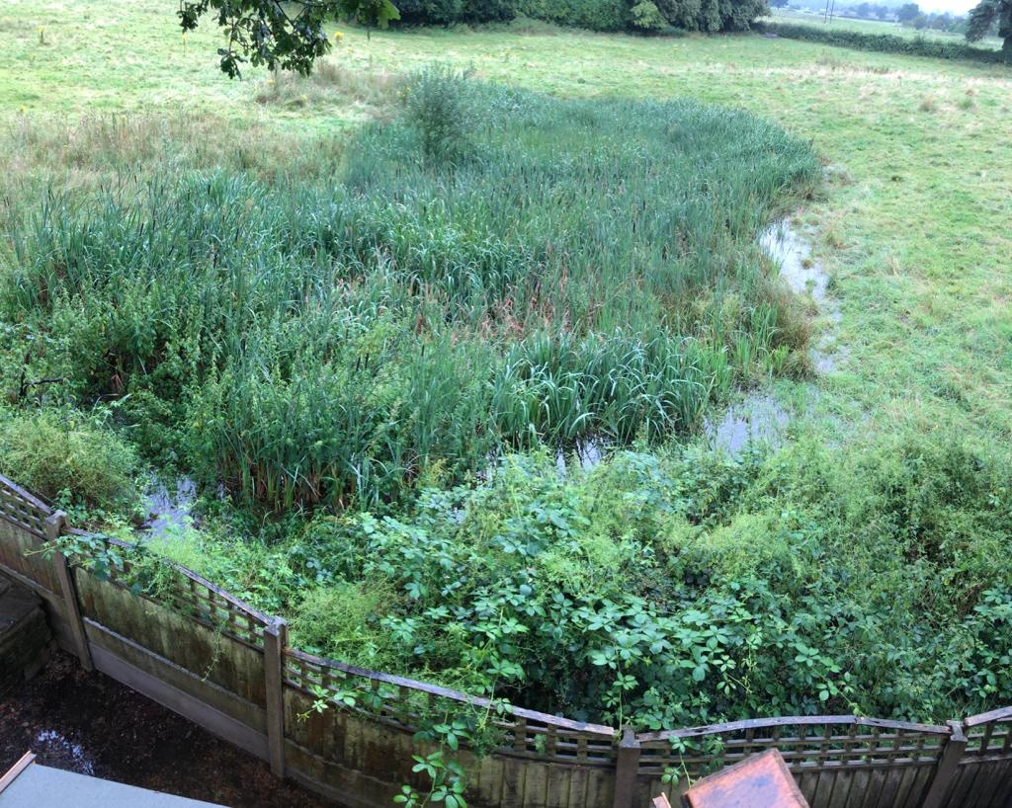
Pond overgrown with reeds on the PRE 2/CFS 574 site Recent flooding in lower Meadow Drive area
adjoining the proposed site allocation

For safeguarding: Site FDR2001 (part of parcel PR09)/Land off Heybridge Lane (northern site)
Prestbury Parish Council object to this site being safeguarded for development and object to the density of development being considered for it which is out of character with this part of Prestbury.
This 3.86 ha. site is land-locked between the West Coast Main Railway Line and houses on the west side of Heybridge Lane (the A538), which is an unlit road that carried 5000 vehicles per day in 1992 when the then Department for Transport proposed an off-line new road nearby (a scheme since dropped). The site promoters are proposing to knock down a large detached property that sits between other large detached, individually-designed properties in order to create an access point.
The convenient re-designation of this Green Belt site by CEC planners is a matter of grave concern to Prestbury Parish Council who question its veracity.
The land proposed for development after 2030 (PRE 3/FDR2001) is a section of a bigger Green Belt parcel (PR09). When the entire parcel was assessed by Arup as part of its 2015 Green Belt exercise, it was deemed to make a ‘significant contribution’ to Green Belt purposes. Their evaluation says:
“The parcel has a significant degree of openness due to the parcel being open farmland and has prevented urban sprawl despite its moderate boundaries. The parcel is bounded by the railway on the western side which creates a strong barrier to prevent urban sprawl and encroachment on the countryside”. (Ref: PR09, page C109, Final Consolidation Report: https://www.cheshireeast.gov.uk/planning/spatial_planning/research_and_evidence/research_and_evidence.aspx).
This report is one of Cheshire East’s evidence documents for the LPS. Notwithstanding that, CEC have carved out a slice of the parcel in question as a result of it being promoted for development in the ‘Call for Sites’ exercise. They have then re-categorised that particular (shield-shaped) section as merely making ‘a contribution’ to Green Belt purposes and used the fact that it ‘only’ has this rating as the ‘special circumstances’ case for Green Belt release. (The residual part of the parcel retains the designation of making a ‘significant contribution’). Furthermore, CEC are prepared to accept the demolition of one top-of the-market detached home (no. 20) in order to provide access and egress to and from the site which, although only 3.8 ha. (9.4 acres) in size is “being considered for around 70 dwellings” (para. 4.117, page 29, PUB 40). This is a part of Heybridge Lane which has an average plot size of an acre that was classed as H12/low density housing in the Macclesfield Borough Plan.
CEC planners identify three criteria which they deem to be ‘red’ on their own traffic light system – landscape impact, brownfield/ greenfield and distance to existing employment areas. PUB 40 says:
“it is within the Bollin Valley local landscape designation area and is visible from a number of public footpaths located near to the site. Overall, it is considered there would be significant landscape impacts that would be difficult to mitigate. However, it may be possible to mitigate impacts by significantly reducing site area to limit development to the area best related to the existing urban form and more distant from vantage points along the existing public rights of way network. The retention of existing landscape features including trees and hedgerows would be very important, alongside very sensitive design and layout with new tree and hedgerow landscape planting to reduce the visual impact” (para. 4.126, page 31).
Bearing in mind that there is a (mapped) natural pond on the site that would have to be avoided, compressing the developable part of it even further to avoid landscape problems would result in a much reduced developable area. This would exacerbate density issues. Also, the reference in the quote above to “urban form” is worrying. There is nothing urban about this rural setting.
It would constitute extraordinary mis-judgement to cram into this site as a whole, let alone part of it (due to a high water table), 70 dwellings which were out of character with their surroundings. It should also be noted that, even though Heybridge Lane is an ‘A’ road, there is no bus service along it and that this section of Heybridge Lane is not connected to mains drainage/sewage systems.
As to potential impacts on flora and fauna of building in this location, these are unknown because the site is inaccessible. This land has mainly been left to its own devices and is thought to support an array of wildlife and habitats. However, because it is such an unknown quantity, it is essential that a proper environmental assessment is carried out here.
If, despite the Parish Council’s misgivings, it is decided to remove this site from Green Belt and safeguard it for future development, it is essential that the area is categorised as being low density, that any development is of a very high quality design and that important wildlife is conserved.
__________________________________________________________________________________
Condensed version of density table from Prestbury Village Design Statement, Jan. 2008, page 16 (https://web.archive.org/web/20110715113019/http://www.prestburycheshire.com/design.pdf)
TABLE 2a: METRIC DENSITIES OF BUILT AREAS
AREA OF VILLAGE | Net area in hectares | No. of dwellings | Average plot size/hectares | Dwellings per hectare
The Village west and south of R. Bollin inc. retail  premises, Spencer Mews & northern tip Macc. Rd. | 2.21 | 41approx | 0.054 | 18.55
New Rd., east of R. Bollin, Pearl St. & Bollin Grove (S) | 0.71 | 40 | 0.017 | 56.3
Old Corn Mill site (Abbey Mill) | 0.61 | 18 | 0.034 | 29.5
Bollin Mews | 0.55 | 24 | 0.024 | 43.6
The Shirleys and Village Mews | 1.0 | 36 | 0.027 | 36.0
Bridge Green | 1.94 | 33 | 0.058 | 17.01
Bollin Grove – mid and N. | 1.49 | 34 | 0.044 | 22.82
Eastern tip of Chelford Rd. & Spencer Brook | 6.04 | 32 | 0.189 | 5.29
Packsaddle Park | 7.41 | 46 | 0.161 | 6.2
Ardenbrook Rise, Chelford Rd. & Collar House Dr. | 8.74 | 36approx | 0.243 | 4.12
Castlegate, Castleford Drive & cul-de-sacs off | 12.8 | 151 | 0.085 | 11.7
Broadwalk, Bollin Way, Paddock Brow and majority of Willowmead inc. cul-de-sacs off | 18.5 | 167 | 0.111 | 9.0
Southern end, Willowmead | 3.0 | 43 | 0.07 | 14.3
North Macclesfield Rd (Dale Brow) & Ashbrook Dr. | 2.67 | 41 | 0.065 | 15.3
Dale Head Rd., Squirrels Chase & the part of  Macclesfield Rd. in the vicinity of them | 8.56 | 34 | 0.25 | 4.0
Summerhill Rd. S. Macclesfield Rd.& Four Lane Ends | 13.79 | 41 | 0.34 | 2.9
New Rd. N.E. from R. Bollin, Butley Hall, Bridge End Lane (W) & Bridge End Dr. | 5.66 | 44 | 0.13 | 7.7
Coachway, Brocklehurst Dr., Orme Close, Badger Road & Peters Close | 4.71 | 54 | 0.087 | 11.46
Parkhouse Dr., Parkhouse Lane, The Fold & Nether Fold | 2.4 | 68 | 0.035 | 28.3
Butley Lanes | 3.43 | 30 | 0.11 | 8.7
Legh Road | 4.28 | 49 | 0.087 | 11.45
Prestbury Lane, Heybridge Lane, Bridge End Lane (E) | 23.46 | 74 | 0.32 | 3.15
Yew Tree Way, Yew Tree Cl., Oakwood Dr., Meadow Dr. & Little Meadow Cl. | 15.21 | 116 | 0.13 | 7.63
Butley Town, London Rd., Ashtree Cl. Lincombe Hey & Dumbah Lane (W) | 8.01 | 49 | 0.16 | 6.1
Castle Hill, Saddleback, Withinlee Rd. (south side), Tudor Dr. & Holmlea Way | 19.17 | 88 | 0.22 | 4.5
In order to establish housing densities, the residential areas have been divided into geographic zones. Where possible, those of broadly similar character, age or density have been grouped together. The net area has been measured to include garden plots but exclude highways, pavements, footways, car parks, the primary school, churchyard and public open spaces. Isolated properties and farms in the Green Belt have not been included in the table. ___________________________________________________________________________________________________
Table 4 Note that, with the exception of Summerhill Road and the southern end of Macclesfield Road, Prestbury Lane and Heybridge Lane (4th row from bottom) have the lowest densities in the parish of Prestbury
GENERAL REQUIREMENTS
Policy GEN 1 – Design principles
Prestbury Parish Council strongly support the first of the proposed design development principles:
“contribute positively to the borough’s quality of place and local identity through appropriate character, appearance and form in terms of scale, height, density, layout grouping, urban form, siting. Good architecture, massing and materials. Development that fails to take the opportunity to support the quality of place of the local area will be resisted”.
It is to be earnestly hoped that this is adopted through the present process. If it is, then Prestbury Parish Council cannot envisage how this principle could align with the inappropriate densities proposed for all three sites allocated for development within Prestbury Parish.

HOUSING
Policy HOU 12 – Housing density
Prestbury Parish Council does not support this policy which attempts to set an average standard density for new developments of 30 dwellings per hectare across the whole borough, despite the huge variations that exist – not only between settlements but within them.
Such a wide-sweeping policy runs contrary to declamations made elsewhere in the Local Plan about the importance of maintaining the character of different areas and it is in contravention of Policy GEN 1 on Design Principles in this SADPD.
It is a defining characteristic of many rural and semi-rural areas that they have low density. It is that lack of mass and the spaces between buildings which makes them what they are.
Prestbury in fact has varying densities in different parts of the parish and, in the Village Design Statement, there is a density table (reproduced in a condensed format as Table 4 in this submission). The highest density, as would be expected, is in the village centre. New Road, east of the River Bollin, Pearl Street and Bollin Grove have a density of 65.3 dwellings per hectare. However, Prestbury Lane, Heybridge Lane and Bridge End Lane, taken as a whole, have a density of 3.15 dwellings per hectare. (Page 16, Village Design Statement for Prestbury Parish, January 2008 - https://web.archive.org/web/20110715113019/http://www.prestburycheshire.com/design.pdf).
Such hugely varying densities in just one parish demonstrates the need for a much more nuanced policy in the Local Plan – one that will help preserve the characteristics of different parts of different areas.
If it so happens that a particular area is defined by low density, then it would be at odds with good design and good sense to impose on that area a development that was significantly denser. The Macclesfield Borough Local Plan accepted this and had a low density designation of, first of all H10 and later H12, which applied to several parts of Prestbury and to some other settlements as well (including Alderley Edge). It included all three areas selected for development in Prestbury in the publication draft of the SADPD. (See illustration no. 1 in this submission).
In order to retain the character of areas defined by low density this policy on density needs to be expanded and adapted to define and represent them and they need to be clearly shown on the policies map.
APPENDIX 1
Email received by Prestbury Parish Council on Sunday September 15th 2019
relating to site allocation PRE 2/CFS 574:
Land South of Prestbury Lane

SADPD consultation re Site CFS574 - possible siting of Great Crested Newts

Sun, 15 Sep 2019 15:06
John Loebl (john.loebl@ntlworld.com)To:you + 1 more Details

Dear Councillor Burns,

We refer to the ongoing consultation on the SADPD and specifically the proposed allocation of site CFS574 for residential development. We live at 45 Meadow Drive, Prestbury. Our back garden is adjacent to the boundary of site CFS574.

The residents of 51 Meadow Drive, Chris and Vicky Stevenson, have found newts in their garden on a number of occasions over the past 12 months. They have forwarded photographs of the newts found to us because they believed them to be Great Crested Newts. We forwarded the photographs to a specialist organisation that identifies rare species, SureScreen Scientifics. Based solely on the photographs, they consider it extremely likely that the newts are Great Crested Newts. We have attached the email correspondence with SureScreen Scientifics below. We have also attached copies of what are referred to in the email correspondence from SureScreen Scientifics as “the 3rd and 4th photographs”. Further photographs exist should you require them.

The newts were found in the garden of 51 Meadow Drive, approximately 70 metres from the boundary of site CFS574 with our back garden and approximately 96 metres from the pond that is within the site (see photograph attached below).

Given the need to protect rare species, we consider it to be of extreme importance that the possible upset to any population of Great Crested Newts in the vicinity of site CFS574 that would be caused by the proposed development of the site is fully explored.

We look forward to hearing from you.

Yours sincerely

John and Lorraine Loebl
45 Meadow Drive
PRESTBURY
SK10 4 EY

Attachments

From: SureScreen Scientifics <scientifics@surescreen.com>
Date: 12 September 2019 at 13:44:51 BST
To: Lorraine Loebl <lorraine.lobel@ntlworld.com>
Subject: Re: Great Crested Newts????
Hi Lorraine,

thanks for the email,

We're pretty certain the 3rd and 4th photos are a female GCN. the first 2 and the last 2 photos we can't be sure of.

Hope this helps, if you have any further queries, please just ask.

Many thanks
Steph Logue

From: Lorraine Loebl <lorraine.lobel@ntlworld.com>
Sent: 12 September 2019 11:18
To: SureScreen Scientifics <scientifics@surescreen.com>
Subject: Great Crested Newts????

Hello,
Thank you for speaking to me this morning. Regarding our conversation I have attached some photos of the newts. In your opinion do you think they could be Great Crested?
I look forward to hearing from you.
Kind regards,
Lorraine L

